PART B
(PART B: TO BE COMPLETED BY STUDENTS)

Roll. No.: C-60 | NAME: Avdhut Madhavi
Class: C | Batch:C2
Date of Experiment: | Date of Submission:
Grade:

B.1: Read the given question carefully and write SQL statement
Students are required to write and execute at least 15 SQL statements based on Views and Nested Queries using their Lab 1 database.
The queries should include:

- Create a view on a single table
- Display data from the view
- Create a view using multiple tables
- Create a view using WHERE clause (MarksView type)
- Drop a view
- Single row subquery
- Subquery using IN
- Subquery using ANY
- Subquery using ALL
- Subquery using EXISTS

Aim: To perform practical implementation of SQL commands for creating views and executing nested queries.

Database: Cinema Ticket Booking System (cinema_db)

1. Create a view on a single table

CREATE VIEW customer_view AS
SELECT customer_id, customer_name, city
FROM customer
WHERE city IS NOT NULL;

SELECT * FROM customer_view;

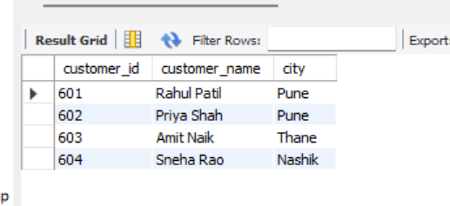

Explanation: Creates a view displaying customer IDs, names, and cities for customers whose city is not NULL.

2. Display data from the view

SELECT * FROM customer_view;

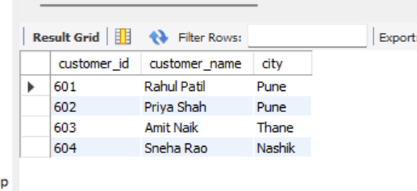

Explanation: Displays the records returned by customer_view.

3. Create a view using multiple tables

CREATE VIEW movie_schedule_view AS
SELECT m.movie_id,
m.title,
s.show_date,
s.show_time,
s.ticket_price,
sc.screen_name,
t.theatre_name
FROM movie_details m
JOIN showtime s
ON m.movie_id = s.movie_id
JOIN screen sc
ON s.screen_id = sc.screen_id
JOIN theatre t
ON sc.theatre_id = t.theatre_id;
SELECT * FROM movie_schedule_view;
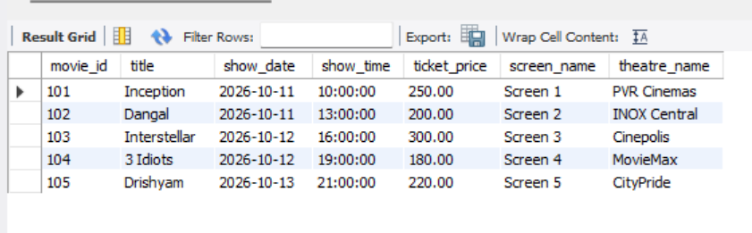

Explanation: Combines movie, showtime, screen, and theatre details into one view.

4. Create a view using a WHERE clause
CREATE VIEW expensive_show_view AS
SELECT show_id, movie_id, show_date, show_time, ticket_price
FROM showtime
WHERE ticket_price > 200;

SELECT * FROM expensive_show_view;

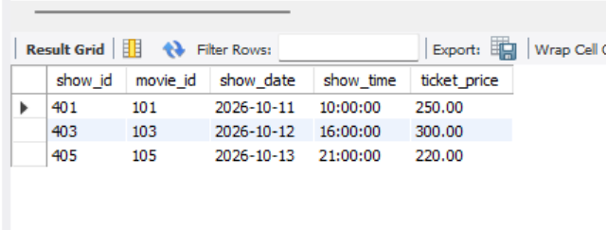

Explanation: Creates a view containing only shows with ticket prices above 200.

5. Drop a view
DROP VIEW expensive_show_view;

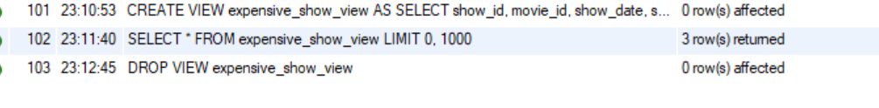
Explanation: Removes the view definition. It does not delete records from the original showtime table.

6. Single-row subquery: Find the show with the highest ticket price

SELECT show_id, movie_id, ticket_price
FROM showtime
WHERE ticket_price = (
SELECT MAX(ticket_price)
FROM showtime
);

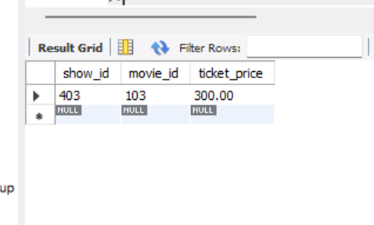

Explanation: The inner query finds the maximum ticket price. The outer query displays the show or shows with that price.

7. Single-row subquery: Find shows priced above the average
SELECT show_id, movie_id, ticket_price
FROM showtime
WHERE ticket_price > (
SELECT AVG(ticket_price)
FROM showtime
);
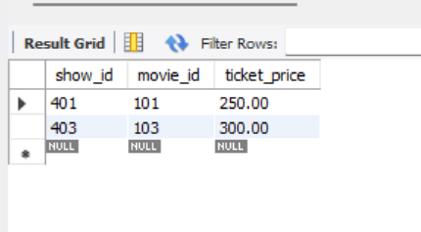

Explanation: Displays shows whose ticket prices are greater than the average ticket price.

8. Subquery using IN: Find movies that have scheduled shows
SELECT movie_id, title
FROM movie_details
WHERE movie_id IN (
SELECT movie_id
FROM showtime
);

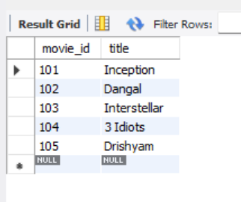

Explanation: Displays movies whose IDs appear in the showtime table.

9. Subquery using IN: Find customers who have bookings
SELECT customer_id, customer_name
FROM customer
WHERE customer_id IN (
SELECT customer_id
FROM booking
);

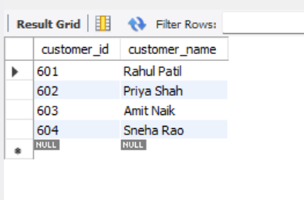

Explanation: Displays customers whose IDs appear in the booking table.

10. Subquery using ANY: Find shows priced above at least one show on October 11
SELECT show_id, ticket_price
FROM showtime
WHERE ticket_price > ANY (
SELECT ticket_price
FROM showtime
WHERE show_date = '2026-10-11'
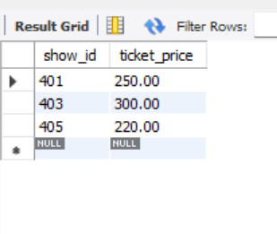
);

Explanation: Returns shows whose ticket price is greater than at least one ticket price among the shows scheduled on October 11, 2026.

11. Subquery using ALL: Find shows priced above every show on October 11
SELECT show_id, ticket_price
FROM showtime
WHERE ticket_price > ALL (
SELECT ticket_price
FROM showtime
WHERE show_date = '2026-10-11'
);

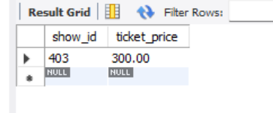

Explanation: Returns shows whose ticket price is greater than every ticket price returned by the inner query.

12. Subquery using EXISTS: Find customers who have bookings
SELECT c.customer_id, c.customer_name
FROM customer c
WHERE EXISTS (
SELECT 1
FROM booking b
WHERE b.customer_id = c.customer_id
);

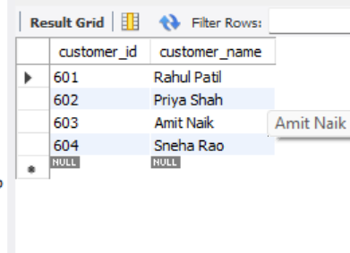

Explanation: Displays customers for whom at least one matching booking record exists.

13. Subquery using NOT EXISTS: Find customers who have not made bookings
SELECT c.customer_id, c.customer_name
FROM customer c
WHERE NOT EXISTS (
SELECT 1
FROM booking b
WHERE b.customer_id = c.customer_id
);

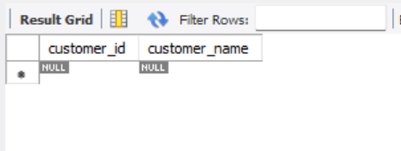

Explanation: Displays customers who have no matching records in the booking table.

14. Nested query: Find movies with above-average ticket prices
SELECT movie_id, title
FROM movie_details
WHERE movie_id IN (
SELECT movie_id
FROM showtime
WHERE ticket_price > (
SELECT AVG(ticket_price)
FROM showtime
)
);

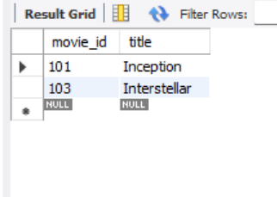

Explanation: The innermost query calculates the average ticket price. The next query finds movie IDs with prices above that average, and the outer query displays their titles.

15. Create a view for confirmed bookings
CREATE VIEW confirmed_booking_view AS
SELECT b.booking_id,
c.customer_name,
b.show_id,
b.booking_date,
b.status
FROM booking b
JOIN customer c
ON b.customer_id = c.customer_id
WHERE b.status = 'CONFIRMED';

SELECT * FROM confirmed_booking_view;

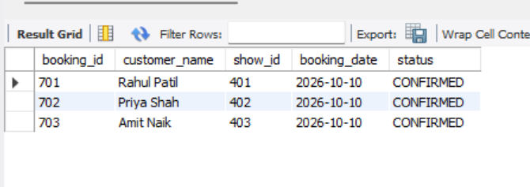

Explanation: Creates a view containing confirmed bookings and the corresponding customer names.

B.2: Observation

Write the observation based on the execution of the above queries.

- Views were created using the CREATE VIEW statement to display selected information from the Cinema Ticket Booking System database.
- Data was retrieved from views using the SELECT statement.
- A view using multiple tables was created by applying JOIN operations.
- The DROP VIEW statement was used to remove a view.
- Single-row subqueries were used to find maximum and average ticket prices.
- The IN operator was used to identify movies with scheduled shows and customers with bookings.
- The ANY and ALL operators were used to compare ticket prices with values returned by subqueries.
- The EXISTS and NOT EXISTS operators were used to identify customers with and without bookings.
- Nested queries were used to retrieve movies based on average ticket prices.
Result: Views and nested queries were implemented and practised using MySQL Workbench.

B.3: Viva Questions Viva Answers
- What is a View?
A view is a virtual table created using a SQL query. It displays selected data from one or more underlying tables.
Example:

CREATE VIEW customer_view AS
SELECT customer_id, customer_name
FROM customer;

- Does a View store data?

A normal view does not store its own copy of the query results. It retrieves data from the underlying table or tables when queried.

- What is a Subquery?
A subquery is a SQL query written inside another SQL query. It provides a result that the outer query can use.
Example:
SELECT show_id, ticket_price
FROM showtime
WHERE ticket_price > (
SELECT AVG(ticket_price)
FROM showtime
);

- What is the use of the IN operator?
The IN operator checks whether a value matches any value in a list or the result returned by a subquery.
Example:
SELECT movie_id, title
FROM movie_details
WHERE movie_id IN (
SELECT movie_id
FROM showtime
);

- What does EXISTS do?
The EXISTS operator checks whether a subquery returns at least one row. It evaluates to true when a matching row exists.
Example:
SELECT c.customer_name
FROM customer c
WHERE EXISTS (
SELECT 1
FROM booking b
WHERE b.customer_id = c.customer_id
);

